“HEAD BACK at IMPACT”
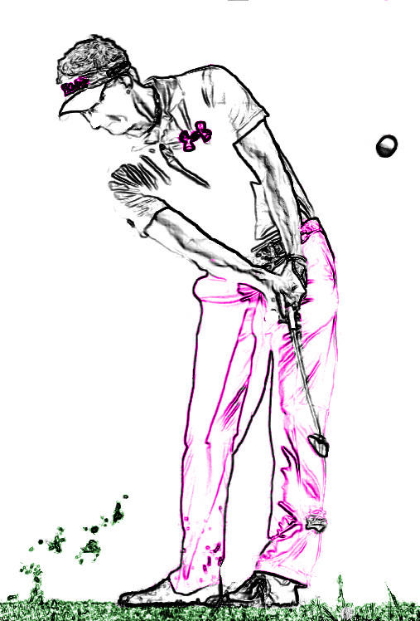
Often we hear the phrase “KEEP THE HEAD DOWN” at impact! Now although this is partly true, we always want to make sure that at IMPACT we KEEP THE HEAD BACK! Too often we concentrate on keeping the head down too long when in fact that somewhat restricts the body from effectively turning through the shot. In other words, in order for the body to release through the shot, the head must follow suit! What we want to concentrate on more than anything at the IMPACT POSITION, is keeping the head behind the ball. When we do this, it allows our body to act like a corkscrew, in turn creating a very powerful and effective way to release the arms and hands throught the shot, all the while creating EXTENSION! The most common flaw I see with people at impact, is a head that has slid too far forward past the ball instead of body that is rotating and clearing with the head staying back behind the ball. A good way to feel proper position is to PICTURE A WALL running straight up from the ball against the front side of your face! After we stike the ball, the rotational force of the body will then move our head forward a little which is perfectly fine but work hard to STAY BACK not necessarily STAY DOWN at IMPACT! Good luck, stay patient and practice effectively!

TYLER HALL
DIRECTOR OF INSTRUCTION
Cell 973.223.6210
Shop 973.859.1726
www.tylerhallgolf.com

